Timothy McReynolds

Part 1)

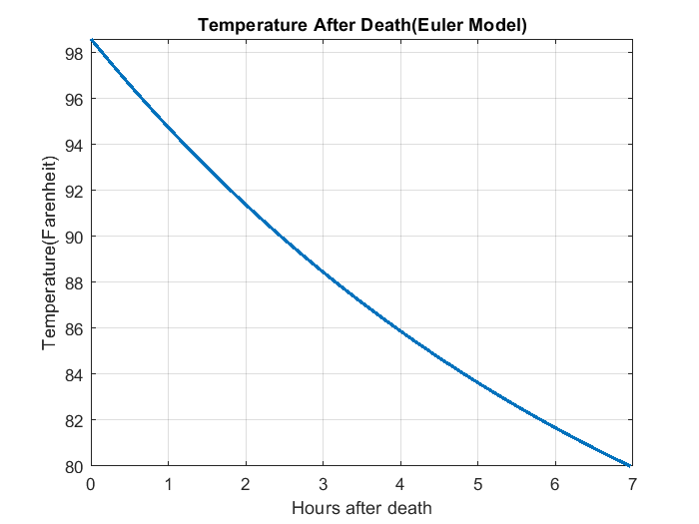

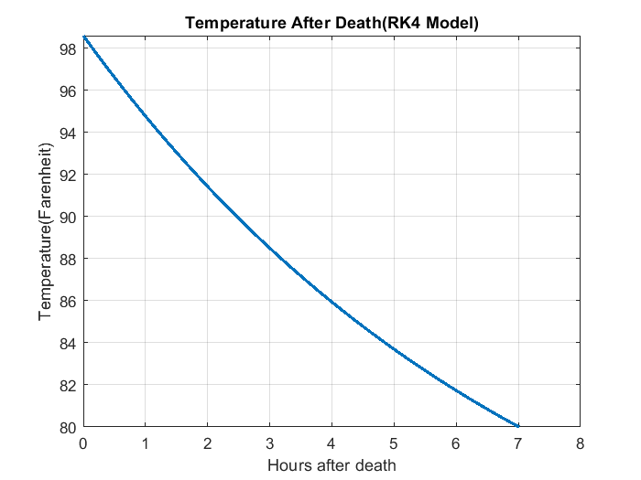

Part 2)

The victim’s body reached 80◦ F approximately 7 hours after time of death. Since the temperature of the body was taken at 10:23pm, the victim died around 3:23pm.